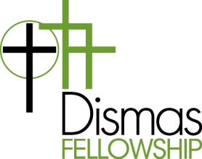The Dismas Fellowship Vision
The Dismas Fellowship is a safe and welcoming place where ex-prisoners and friends can experience Christian community. Dismas is the name given to the good thief on the cross who prayed to Christ: “Jesus remember me when you come into your kingdom”.

Role Description for Dinner Preparation Team
Thank you for volunteering to be part of the Dinner Preparation Team and for helping to provide the meal for the Dismas Fellowship. The Dinner Preparation team plays a vital role in creating a welcoming place where ex-prisoners, their friends and families can find Christian community. Below are some of the key responsibilities of this important position:
- The sharing of a meal is central to the Dismas Fellowship. As part of the team that will prepare this meal, you are providing an important act of kindness.
- In Toronto an average Dismas evening will have between 50-65 people in attendance, so please plan to provide food for 55 which will allow for some leftovers for Fellowship members.
- The church will be open by 3PM for the Dismas Fellowship. You will have access to the kitchen, which has three ovens that can be used to heat up the main course.
- It is preferred that the main course be brought to the Church in aluminum pans that can be heated. This will greatly reduce preparation time.
- The meal should consist of the following:
  - Main Course (serve more than needed…Recipes available)
  - One small vegetarian main course
  - Salad and salad dressing
  - Vegetables
  - Buns & Butter
- Members of the Fellowship will provide desserts. Your team may also bring desserts if you would like. At each Dismas Fellowship meeting, we have a large cake to celebrate birthdays and other successes –we will provide this.

